**WINDOWS SERVER REFERENCE**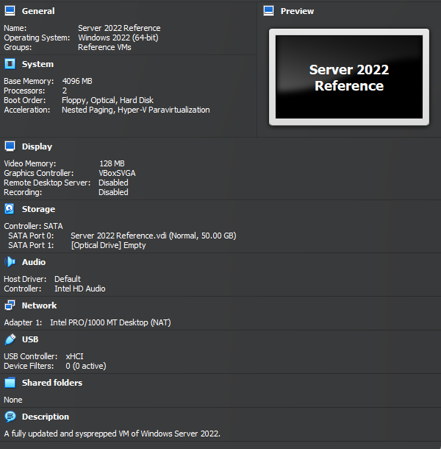

**WINDOWS 10 REFERENCE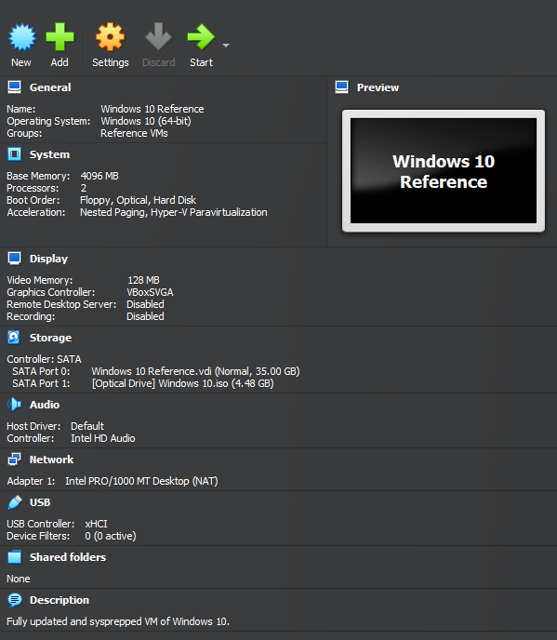WINDOWS 11 REFERENCE**